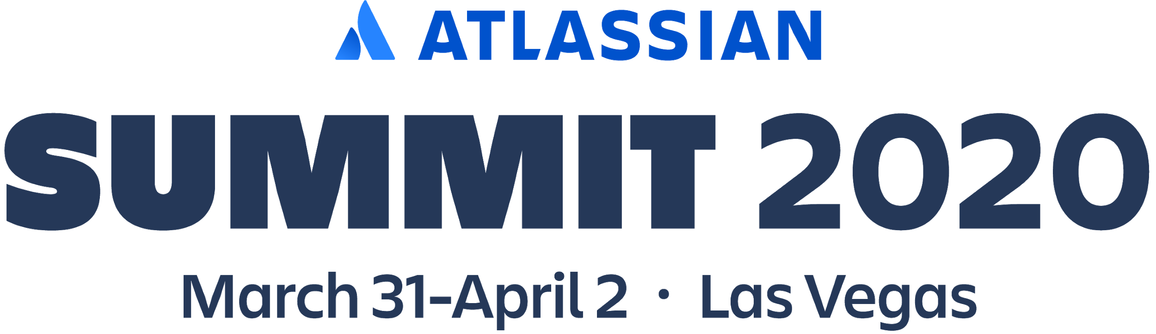

Dear NAME,

Atlassian will be back at the Mandalay Bay in Las Vegas for Summit 2020! You won't want to miss our biggest flagship event.
Discover all the new ways to improve your work day, work place, and work life with all-new tracks and inspiring sessions around personal growth, productivity, scaling agile and more. Network with leaders and teams like yours, and get a first look at what's coming down our product pipeline.
To celebrate, we're offering you an extra discount on top of Early Bird pricing.
- Your Summit 2020 pass – $XXX.XX
- Early Bird Summit pass - $750
- Standard Summit pass – $1,400
This deal is only available for a limited time, so get your pass today!

Cheers,
NAME

